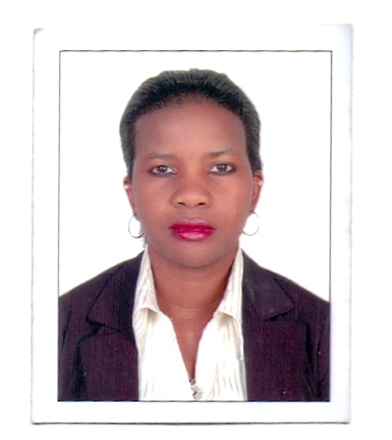
norah8299@gmail.com
NAMUDDU NORAH
DUBAI-UNITED ARAB EMIRATES
+971524343984
Seeking for a butler /waitress positon basing on the best knowledge 0f guest service accompanied by best skills in food and beverage and housekeeping details that build me up to be fit for butler position in any luxury hotel with 5 years experience
DUTIES AND RESPONSIBILITIE
1 –welcoming and greeting the guest in polite manner
2-Assiting the guest with check in duties with help of front agent desk
3-Making sure the the room checked in is up to the standard as per guest request with all amenities
4-following up all this requests and needs during his/her stay
5-making sure that the guest is comfortably feeling at home

HOSPITALITY WORKING EXPERIENCE waitress

1< 2018 - till date- HILTON, V and ALHBOOTOR complex hotel Dubai as waitress (5star)
2> 2015 to 2017 Yas island rotana Abu Dhabi as room service waitress (5star)
3>2013 to2014 Etihad terminal 3 lounge as lounge attendant (5star )

VALID CERTIFICATES ACHIEVED.

Waitress certificate by Rotana
Room service order taker by rotana hotel

EDUCATION BACK GROUND.
YMCA Uganda
High school College from 2005 to 2010 @ kajjansi progressive
Primary school from 1991 to 1999 @ Bat valley

PERSONAL INFORMATION
Nationality – Ugandan
Gender – Female
Language –fluent English
Passport NO.B0957933
Religion –Christian
Status –single.
HOBBIES
Swimming
Reading
Watching movies .

