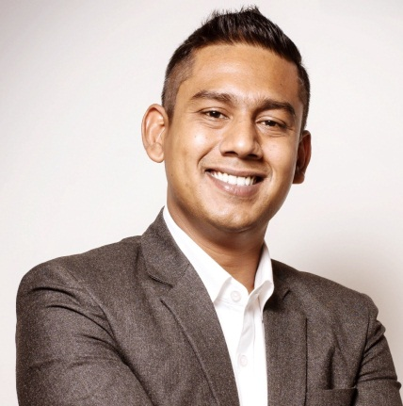

Mr. Ajoy Biswas

E Mail: ajoy.biswas09@yahoo.com / ajoy.biswas09gmail.com
Personal: +966571690804

Director of Spa

A BRIEF OVERVIEW

- Yoga Instructor
- Developing SOP & Core policy
- Leadership Skills
- Strategic Planning
- skill
- Grooming
- Engagement activities
- Event organization
- Budgeting & Cost Control
- Pricing Strategies
- Daily Reports
- Quality Control
- Customer Satisfaction
- Training and Development
- Inventory Control
- Procurement & Sourcing
- Liaising & Coordination
- Health, Hygiene & Safety
- Performance Management
- Recruitment & Trainings
- Monthly Targets
- Resource Optimization

- A dynamic professional with more than 13 years of rich multi-cultural and global experience in Operations and Development.
- Comprehensive experience in managing Spa operations including Grooming menu-planning, monitoring Inventories, Regular checks on the quality of treatment done by therapists.
- Creating procedures, service standards, operational policies and guidelines for maintaining quality & hygiene quality standards with clear understanding
- Profound sensitivity to multinational cultures & consumer behavior with skills in interacting with customers from different nationalities, meeting their requirements through efficient customer handling skills &molding plans according to their feedbacks.
- Developed competency in developing SOPs as well as establishing a performance-driven culture that ensures accountability and personal ownership, training the juniors & developing service standards & operational policies for business excellence.

Organizational Experience

Director of Spa (Present)

Narcissus hotel and spa (Saudi Arabia Riyadh)

Spa Name: Narci spa
Spa Size: 10000 Sqmt
Team size: 35 Staff Spa facility: 8 rooms,12 spa suits , 2 Fitness center, 2 wet area with 4 Jacuzzi, 1 indoor pool, unisex salon, Yoga Class etc.

Spa & Recreation Manager

Le meridian hotel (pre-opening )

Spa Name: LE Spa
Spa Size: 57000 Sqft
Team size: 25 Staff Spa facility: 8 rooms, Fitness center, 2 wet area with 4 Jacuzzi, 1 indoor pool, unisex salon, Yoga Class etc.
Key product: Clarins

Spa & Recreation Manager

Saj Resort,(pre-opening)

Urban Nirvana Wellness,(Mahabalashwar):-
Spa Name: Escenza Spa
Spa Size: 13000 Sqft
Team size: 18 Staff
Spa facility: 10 rooms,1 Swimming Pool, Fitness center etc.
Key product: Thalion, Forest Essentials, Jun Jacobes.

Evolve Wellness Salon and Spa,(pre-opening)
(Sonipath ,panipath , Rothak):- Spa & Salon Manager

Vibes health care PVT ltd(Kolkata) :

Spa and Physiotherapist (Mar 2004-July 2009)

IT Exposure :

Diploma in Computer Applications PC operation entailing Basic, Windows-2000, Office-2000, MS-Power-Point, MS-Excel, MS-Word & Internet. Software like , Micros, opera and Zenoti,Inky

Professional Courses
•PHYSIOTHERAPY (WEST BENGAL STATE COUNCIL OF TECHNICAL EDUCATION)
•CERTIFICATE IN YOGA (WORLD YOGA SOCITY KOLKATA)
•SCIENTIFICAL MASSAGE MASTER THERAPY (WORLD YOGA SOCIETY KOLKATA)
•TEACHERS TRAINING (WORLD YOGA SOCITY)

Education

•Passed Class 10th under WBBSE 2000
•Passed H.S. under WBCHSE 2002
•Graduated in B.com. from C.U. in 2005

Address Saudi arabia ,Riyadh
Date of Birth : 01/10/1984.
Marital Status : Married.
Nationality : Indian
.
Leisure Activities : Yoga, Hockey, Football, Fitness, Swimming, Athletic.
Reference

Date :
Place : Saudi Arabia , Riyadh

