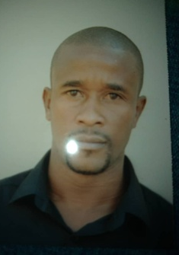
Merwin Nguvauva
Erf 4583 Lu-ami Street,Soweto Windhoek
P.O.Box 23538 Windhoek ,Namibia
bennizomn@gmail.com
+971502801676

PERSONAL BACKGROUND

Date of Birth 20 September 1987
Gender Male
Place of Birth Grootfontein
ID Number 87092000475
Citizenship Namibian
Health status Excellent
Marital status Single
Religion Christian
Languages English, Afrikaans, Otjiherero

EDUCATIONAL QUALIFICATION

School Okakarara Secondary School
Subjects Accounting, English, Otjiherero, Biology, Economics and Mathematics
Grade 12
Year 2005

PERSONAL AMBITIONS

Very hard working and diligent
To contribute to my country ultimate goal objective
To embrace and take up any challenge
To work to achieve the highest level of my abilities and potential

career history

- Name of the companY: Shoprite Supermarket
Position Shelf packer
Period 2008-2010

- Name of the companY: Spur Mountain Eagles
Position Waiter
Period 2014-2016

- Name of the companY: IIamo Restaurant Hosea Kutako InternationAL AIRPORT
Position Waiter
Period 2016-2017

- Name of the companY: Hekland Catering
Position Supervisor
Period 2017-Current

HOBBIES

Singing and team work related activities.
Surf the Net (information update on current affairs)
Reading the Newspaper
Playing Soccer

REFERENCES

1. Mr. A. Tuly
Spur Mountain Eagle
Supervisor
Cell No: +264817273995

2. Mr. Kenangongo Zaongara
Community Activist
Cell: 081 3628428

3. HEKLAND CATERING
P.O. Box 99984 Otjomuise
Tel: +264815900779
Email: heklandgroup@gmail.com

