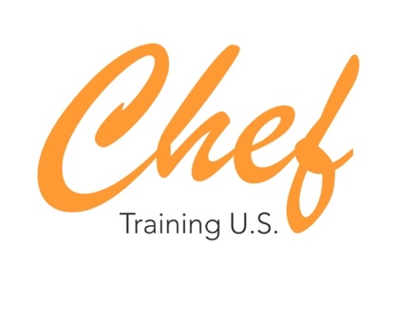
Chef training U.S

At Chef Training U.S. we are looking for Representative in Spain and Ambassadors all around the world. We are a company located in New York and Miami that offers paid internships in U.S. for young culinary talents. If you are in the field and want to be your own boss, this is your job.

- Position Available: Spanish Representative and Ambassadors
- Location: TBD
- Duration: 12 months
- Start Date: All year
- Stipend: Depending on experience.
- Hours: 40 hours / week
- Requirements: High English level, self-management.
- Conditions: commissions. Availability to travel.

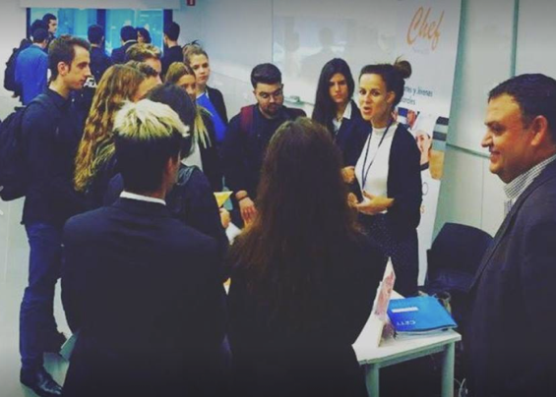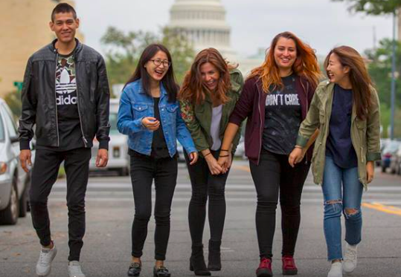

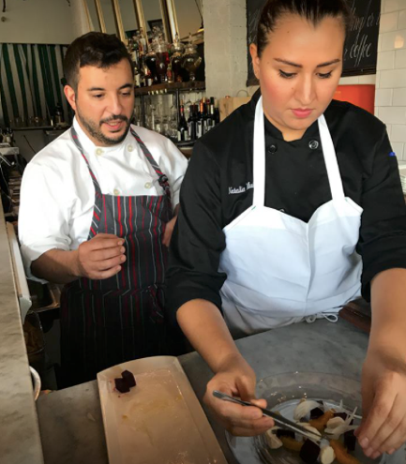

If you wish to apply for any of our opportunities, please send your resume to info@chef-us.com and contact us through phone, message or WhatsApp to +1 917 312 5184 from Monday to Friday during New York Business hours: from 9:00 a.m. to 6:30 p.m. For more information, please visit our website www.cheftrainingus.com

