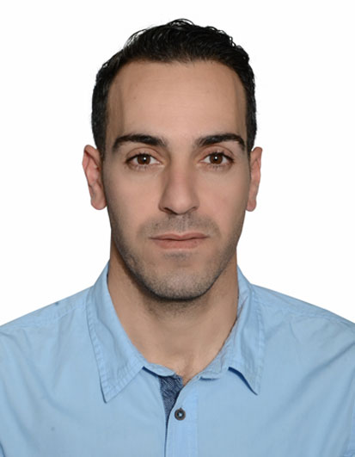
CAREER OBJECTIVE
Talented and experienced Arabic head chef trained and studied in preparing and supervising the preparation of foods of all Arabic types.
Adept at managing all food-related personnel and activity in the hospitality field in the best ways to cook, design and present foodstuff.

Jamal Jamous

Contact Information
Mobile No.:
+971555546569
E-mail Address: jamal_jamous@yahoo.com

Date of Birth: 20, Dec,1982
Nationality: Syrian
Status: Married
Address: Dubai, UAE.
Visa status: Employment
visa.

QUALIFICATION:
Higher Diploma Degree in Hospitality Management
(Vocational Institute of Hotel Management-Damascus-Syria (2001-2003)

Language Proficiency:
Arabic : Mother Tongue
English: Excellent

Reference
Available As per request
CORE OF SKILLS & KNOWLEDGE
(High filed awarding body for compliance certifies, person in charge certificate Quality ISO 9001:2000, EMS ISO 14001, Telephone Techniques, Guest Care, Health & Safety, Procedure in the event of fire, Procedure in the event of Accident).
Leadership skills: trained and developed other chefs in their cooking skills in accordance to food safety standards.
On job-Job Training: Menus, SOP, Valued guest,
Achieving excellence, HACCP, Emergency and health,
Food Hygiene, ISO 22000–Proficiency in MS Office.

WORK EXPERINCE

Restaurant chef
Nikki beach resort and spa
Dubai UAE
01st February,2016 up to present
Key Responsibilities:
- Planning, directing, and supervising the food preparation and cooking activities of the kitchen.
- Coordinate planning, budgeting, and purchasing for all the food operations within the restaurant
- Determining how food should be presented, and create decorative food displays.
- Determining production schedules and staff requirements necessary to ensure timely delivery of services.
- Estimating amounts and costs of required supplies, such as food and ingredients.
- Inspect supplies, equipment, and work areas to ensure conformance to established standards.
- Instructing cooks and other workers in the preparation, cooking, garnishing, and presentation of food.
- Monitoring sanitation practices to ensure that employees follow standards and regulations.
- Order or requisition food and other supplies needed to ensure efficient operation.
- Arranging for equipment purchases, repairs and correct storage .
- Preparing and cooking foods of all types, either on a regular basis or for special guests or functions.
- Supervising and coordinate activities of cooks and workers engaged in food preparation.
- Collaborating with other personnel to plan and develop recipes and menus, taking into account such factors as seasonal availability of ingredients and the likely number of customers.
- Checking the quality of raw and cooked food products to ensure that standards are met.
- Checking the quantity and quality of received products.
- Demonstrating new cooking techniques and equipment to staff.
- Developing and maintain standard authentic recipes.
- Training Chefs to produce authentic food.
- Ensuring that all food, hygiene and sanitary standards are well practiced by all food handlers.
Arabic Head Chef
Taj Dubai Hotel
Dubai UAE
01st may, 2015 up to 31st January 2016

Key Responsibilities:
- Preparing menus for corporate events, weddings, birthday parties and other occasions at the hotel.
- Delegating and supervising responsibilities of trainees.
- Managing careful practices of raw material, safe food handling procedures and cost.
- Ensuring the appropriate and regulated execution of recipes.
- Collaborating with accounting and management to manage finances and inventory.
- Determining ambience of restaurant that worked with menu.
- Developing all team members to their fullest potential and identifying individual training needs.
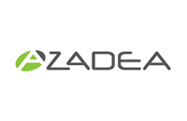
- Conducting daily kitchen briefings.
Head Chef
Azadea Group
KosebasiAnatolinTurkis Grill
(Abu Dhabi)
15th Nov, 2012, up to 30th Apr 2015
(Köşebaşı was founded in 1995 as the first upscale Turkish steakhouse. Consistently rated as one of Europe’s Best Restaurants by Zagat, Köşebaşı serves the authentic taste of eastern Mediterranean cuisine to its guests.
The award winning menu features various mezes, hand grounded and marinated cuts of barbecued meats, traditional Anatolian side dishes and regional breads).

Key Responsibilities:
- Planning, organizing and researching new aspects for the brand products that could contribute to meeting/exceeding set sales targets and share with team members accordingly.
- Training all team members on pastry techniques and hygiene standards.
- Ensuring the conformity of the products according to the company's and the HACCP standards and handle the relevant reports accordingly.
- Preparing high quality menu items and ensure conformity to set recipes of the brand in order to maintain image and customer satisfaction.
- Supervising food production, maintain quality and hygiene standards, displays expert knife skills and seek to continuously improve the image of the operation
- Assuming full responsibility for the costing of all food items produced and oversee the proper storage and reception of food items
- Taking all necessary measures to reduce waste and maintain control acons to aain forecasted food and labor costs
- Controlling and monitor the monthly inventory by making sure the measures set are followed and the discrepancies are adjusted
- Preparing weekly work schedules for all kitchen personnel in accordance with stang guidelines and forecasted labor costs.

Jr.Sous Chef
Conference and Events
&Jumeirah Hospitality
MadinatJumeirah,
The Arabian Resort - Dubai
1st Feb, 2011 – 9th Nov, 2012
(Built around a large lagoon, the Madinat Arena multi purpose venue (MPV) is designed in the style of an old fortress. Within the MPV, a portable seating system, fixed upper gallery, VIP seating and can accommodate up to 4,500 people).

Key Responsibilities:

- Preparing cold and hot mezze Lebanese, oriental dishes other local / arabic food.
- Making all kinds of Arabic Grill and other marinated barbeque items.
- Preparing main courses (Lebanese, Oriental, Moroccan)
- Assisting and reporting to the Chef De Cuisine and Sous Chef in all kind of food preparation.
- Assist senior chef to create menu and recipes.
- Preparing weekly report and HACCP report (action plan, forms etc.)
- Ordering Arabic items using Food and Beverage Management System (FBM system)
- Preparing production list and every function.
- Ensuring the company’s required standards of customer care and services are met and practiced by all staff members.
- Developing all team members to their fullest potential and identifying individual training needs.
Sous Chef
LE Meridian Hotel
(Starwoodhotels.com)
Duba Airport, Dubai UAE
March 16th, 2006 – January 9th, 2011

(Starrted as Demi Chef in Mar 2006 - promoted to Chef de Partie in Jul 2007 then to Sous Chef in Jun 2009)
Key Responsibilities:
- Preparing a market list for the restaurant.
- Handling staff training (On-job/Off-job training) and organizing schedules.
- Ensuring the company’s required standards of customer care and service are met and practiced by all staff members.
- Arranging menus for the outlet
- Acting as a communication link between the management and the restaurant team.

Demi Chef De Partie
Al Maloof Restaurant
Dubai UAE
Apr, 1st 2004 – Feb, 28th 2006

Assistant Cook
Umayya Hotel Damascus
Syria
Feb, 15th 2001 –Dec,1st2002

Commis Chef
Al Cham Palace Hotel
Damascus, Syria
March 2000 – December 2001

ACHIEVEMENTS:

- Colleague of the Month (Internal Department Culinary)
October, 2011

- Employee of the month for May, September & October 2008
Best in class 2008 (Star Voice)

TRAINING & CERTIFICATES:

- PIC Training – Person IN-Charge
- Basic food and Safety Training and HACCP awareness

Jamal Jamous

