RANDHIR KUMAR
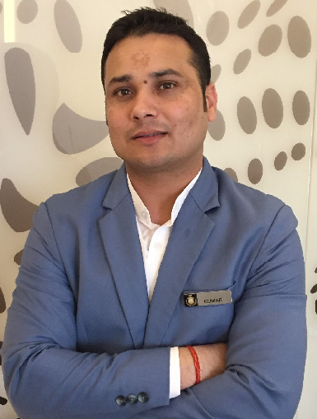  Email:randhirkumartaj@gmail.com  Contact Number:  Mobile: +971506770501  Address for Contact:  Abu Dhabi  Personal Data:  Date of Birth : 03-10-1992  Sex : Male  Nationality : Indian  Marital Status : Single  Languages known:  (Mother Tongue underlined)  English, Hindi  Hobbies:  Traveling, driving, Cricket etc…  Skype id : randhir.kumar746 | Objective  To work in a challenging environment that will expose me to new trends in the world of Tourism and Hospitality. Keeping me skilled to face new challenges and thereby motivating me to apply my skills and knowledge to attain the set goals.  Education  Completed 2yearDiploma in Hotel Management & catering technology  Computer Knowledge  - M.S office.  - Internet.  - Opera Service  Personal Skills  - Comprehensive problem solving abilities.  - Organizing and managing capabilities.  - Willingness to learn and update myself with new methodologies & technologies.  - Positive attitude and team spirit.  - Good communication skill.  - Dedicated, focused, enthusiastic and hard working.  - Creativity.  Reference  Abdulwahab Ghulam -Front Desk Manager- Downtown Rotana Hotel Bahrain 0097333610100  Sulim Beltran Guest service manager  sulim.beltran@rotana.com

Educational Qualifications

- Successfully Completed 2 years Diploma in Hotel management & catering technology
- Successfully completed +2 from Bihar state in Year 2009 from Govt.
- Successfully completed 10th from Bihar state in Year 2007 from Govt.
.

Work Experience
- Royal M Hotel Abu Dhabi as a Bell Captain from 15/09/2018/ to present
- Saadiyat Rotana Resort and villa pre-opening hotel (19/11/2017 to 10/09/2018 as a bellman / concierge
- Downtown Rotana Bahrain as a Bellman Pre-Opening Hotel (16/11/2015 to 15/10/2017)
- Hyatt Regency Chennai India as a Bell Attendant (03/10/2011 to 30/10/2015)
- Hilton Chennai India as Housekeeping Attendant (28/03/ 2011 to 30/06/2011)
Specialization

- Front office
- Bell Captain

Declaration

I hereby declare that the above furnished information is absolute according to the records and to the best of my knowledge.

Place: Abu Dhabi
Date…/……/……… (RANDHIR KUMAR)

