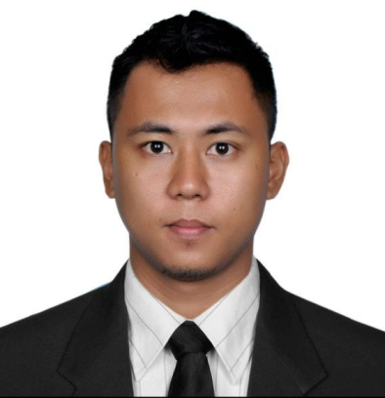
MARK ALDRIN SAN JOSE SANTIAGO

431 Balestier Road Public Mansions S-329813
Mobile +6584100485
E-Mail Address; santiagomarkaldrin28@yahoo.com

PERSONAL / JOB OBJECTIVE

I’m determined, can work in less supervision and easy to work with.

My explicit plan if given the opportunity to work in this company is to work hard as much as I can to support my family and provide a better life for myself. Render tangible performance as to the discharge responsibilities as assigned, be able to carry-out, support present and future operational expansion of the company to which I will be working for.

PERSONAL CIRCUMSTANCES

Date of birth:January 2, 1986
Place our bath:Iriga City, Philippines
Age:31yrs. Old
Weight:60klg
Heights:5”6”
Citizenship:Natural born Filipino
Material status:Single
Religion:Catholic

- EDUCATIONAL ATTAINMENT

Elementary:Holy Child Educational Center, Graduate 1999

High School:Ateneo De Naga University, Graduate 2003

College:Ateneo De Naga University, Units Earned
Course :Computer Science
Apicius Culinary Arts – Naga City January 2016- Decmeber 2016 Diploma Course

- EMPLOYMENT HISTORY

Company Name:Marriott Merlin Beach
(February 6, 2017 to July 21, 2017)
Position Title:Commis II
Role:Chef (Thai Kitchen, Western Kitchen, Cold Kitchen)
Industry:Culinary

Company Name:Cathay Land Corporation
(January 2009 to April 2009)
Position Title:Account Officer
Role:Sale Support Coordinator
Industry:Property / Real Estate

Company Name:High Stakes Poker Club
(October 2011 to December 2011)
Role:Card Dealer
Industry:Casino
Company Name:ACS Xerox Group of Company
(January 28, 2013 to June 30, 2013)
Role:Retention Specialist (Sales Department)
Industry:BPO(Call Center Company)

Company Name:Gracall International MNL
(August 4, 2013 to October 4, 2013)
Role:Customer Service Representative (Phone Agent)
Industry:BPO (Call Center Company)

- SKILLS / QUALIFICATION

- Computer Literate
- Able to Drive Vehicle ( Standard / Manual / Automatic )
- Research Oriented
- Knowledgeable in Cooking Asian Cuisine
- Trained in Card Dealing

REFERENCES

Mr. Marlon Manabat
Sales Manager
Cathay Land Corp.
Robinsons Galleria, OrtigasEdsa
+639176047649

Mr. Jim Roxas
High Stakes Poker
Casino Manager
+639273189268
Paranaque City, Philippines

Mr. Mark Bonife / Mrs. Ethel
Account Manager
Acs Xerox Group of Company
+639273967623 / +639235927088
One E-com CenterHarbor Drive cor. Sunset Drive, SM Central Business Park, Bay City, Pasay City

Chef Anne Radha Po
Chef at Apicius Culinary Arts
Contact number : 09055201660 / 09214687100

Excecutive Sous Mr. Anil Rawat
Marriott Merlin Beach Resort and Spa
+66076335300
+660858855925
anil.r@marriott.com

_________________
Applicant

