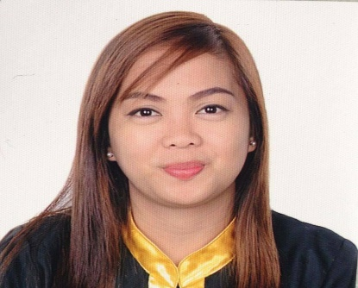
PASCUA, JEZZALINE LOZANO
RasLaffan City Qatar
+97431494654
jezapascua1012@gmail.com

OBJECTIVE

- To employ my knowledge and experience with the intention of securing a professional career with opportunity for challenges and career advancement, while gaining knowledge of new skills and expertise.

EDUCATION

BACHELOR OF SCIENCE IN HOTEL AND RESTAURANT MANAGEMENT
NORTHEASTERN COLLEGE
Villasis, Santiago City Isabela

HR ADMINISTRATION
FILIPINO INSTITUTE
Doha Qatar
August 18-September 22, 2017

EXPERTISE

- Computer literate
- Good Cook
- Administrative & clerical works
- F & B Services and Banquet
- Flower Arrangement
- Cashiering

STRENGTHS

- Good interpersonal and communication skills
- Ability to work effectively under pressure
- Pleasant personality and professional outlook
- Motivated and creative team player with a careful sense of responsibility
- Fast Learner/ Good Listener

TRAININGS AND SEMINARS

Leadership Training
Gracious Angeli Hotel, Baguio City
April 25-28,2008

Hotel Familiarization
Bayview Park Hotel, Manila September 5-7

Banquet, Catering & Flower Arrangement Seminar
Northeastern College, Isabela
February 24, 2010

First National Hoteliers and Restaurateurs
SMX Convention Center, Manila
August 28,2010

On The Job Training
Maines View Park, Baguio City
May 1-June 2, 2011

On The Job Training
Astoria Plaza Full Residential Suite, Pasig City
January 20-March 5, 2013

Visioning/ Telephone Manners Code of Conduct
AKC Seminar, Santiago City Isabela
March 22, 2014

5s of Good Housekeeping
Zen Hotel Café & Restaurant, Isabela
July 2014

Restaurant & Familiarization Training
Salido Restaurant , Ongpin Manila
February – March 10 2014

LICENCES/CERTIFICATION

Bachelor of Science in Hotel & Restaurant Management
S.o #50346201102 July 5, 2013

NATIONAL CERTIFICATE II
Housekeeping
Certificate # 15020403002275
June 18, 2015

HR ADMINISTRATION
Filipino Institute, Doha Qatar August
18-September 22, 2017

HCCP LEVEL 2 TRAINING
Rasgas Plant Cafeteria
June 21-24, 2017

WORK/EMPLOYMENT HISTORY

Waitress/Cashier
SodexoTeyseer Qatar
February 4,2017 to present

Food and Beverages Services
Minami Saki By Astoria
April4-September 4, 2016

Assistant Secretary
UBM Company
December 2015 -March 2016

Cashier
Gorios Yakiniku
December 14,2015-March 14,2016

Food Attendant/Cashier
Isabela Zen Hotel & Restaurant Corp.
March 10, 2014-July 29,2015

On Call Waitress
Cez’sCatering and Services
December 2010-May 2015

Cashier
Jollibee Shell, Santiago City Isabela
August-October 2010

CHARACTER REFERENCES

Ms.Jaquiline Gabriel
Event Planner and Coordinator
Centro East Santiago City
09055423507

PERSONAL PROFILE

Date of Birth: October 12, 1991
Place of Birth: Burgos, CabarroguisQuirino,Phil.
Citizenship: Filipino
Status: Single
Language: English /Filipino

I hereby certify that the above details/information are true and correct to the best of my knowledge, belief and ability.

JEZZALINE L. PASCUA
Applicant

