Rome, June 12, 2015

EMPLOYMENT CERTIFICATE

This is to certify that Mrs. Parente Addolorata, born in Benevento (BN) on July 20, 1988 has been employed by Grand Hotel de la Minerve - Piazza della Minerva, 69 – 00186 Rome, from March 21, 2010 to October 31, 2010, as Restaurant Supervisor and with a full time employment agreement.

During above periods of time, she has proven to be a very dedicated and committed member of team, and performed her duties with interest.

We wish her great success in her future.

Hotel Invest Italiana Real Estate Srl
Human Resources
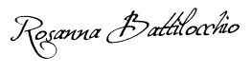
Rosanna Battilocchio

______________________

