SURESH THANKAVEL 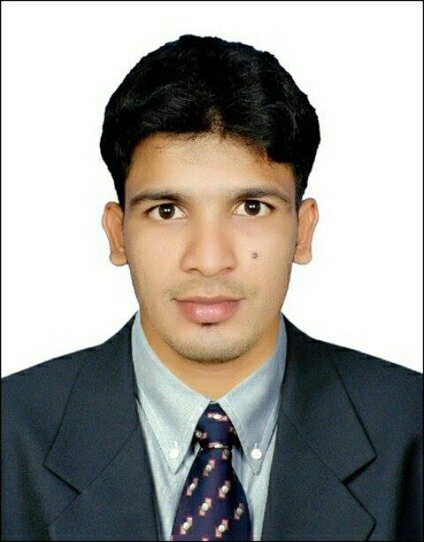
Mobile No: +97333101235
EMAIL :sureshaathe@gmail.com

Objective:

To attain high performing and result oriented profession to lead organization
towards achieving its vision and at the same time to perform my personal and social responsibilities well and to be a successful person.

PRESENTLY – RAMADA HOTEL BAHRAIN
Demi Chef
Since 2016

Responsibilities

- A demi chef relays orders to his station cooks and ensures each menu item his station is responsible for is prepared on time.
- Oversees all preparation, cooking and presentation for plates.
- May be required to assist with cooking, preparation and plating when station chefs are absent.
- Kitchen’s demi chef also ensures that all health and food safety standards are practiced and he helps troubleshoot any kitchen issues that may arise.

Work experience:

CARLUCCIO’S RESTAURNT IN DUBAI
Commi -1
2014 to 2016
Responsibilities

- Support Chef de Partie or Demi Chef de Partie in the daily operation and work.
- Work according to the menu specifications by the Chef de Partie.
- Keep work area at all times in hygienic conditions according to the rules set by the hotel
- Control food stock and food cost in your section.
- Prepare the daily mis-en-place and food production in different sections of the main kitchen or satellites.
- Follow the instructions and recommendations from the immediate Superiors to complete the daily tasks.
- Ensure the highest standards and consistent quality in the daily preparation and keep up to date with the new products, recipes and preparation techniques.
- Coordinate and participate with other sections of requirements, cleanliness, wastage and cost control.

EMPORIO ARMANI CAFFE, the pearl, state of Qatar
COMMI 2
January 2012 to 2014

Responsibilities

- My strong areas are pastry, bakery and cold kitchen and hot kitchen. I prepare home made fresh pastas, different kinds of salads, breads and desserts.”
- Support Chef de Partie or Demi Chef de Partie in the daily operation and work.
- Work according to the menu specifications by the Chef de Partie.
- Keep work area at all times in hygienic conditions according to the rules set by the hotel.
- Control food stock and food cost in your section
- Prepare the daily mis-en-place and food production in different sections of the main kitchen or satellites.
- Follow the instructions and recommendations from the immediate Superiors to complete the daily tasks.
- Ensure the highest standards and consistent quality in the daily preparation and keep up to date with the new products, recipes and preparation techniques.
- Coordinate and participate with other sections of requirements, cleanliness, wastage and cost control.

Intercontinental Hotel Doha, Qatar
COMMI 2
July 2009 to December 2011

Responsibilities

- Follow all company and safety and security policies and procedures; report maintenance needs, accidents, injuries, and unsafe work conditions to manager; complete safety training and certifications.
- Ensure uniform and personal appearances are clean and professional; maintain confidentiality of proprietary information; protect company assets.
- Speak with others using clear and professional language. Develop and maintain positive working relationships with others; support team to reach common goals; listen and respond appropriately to the concerns of other employees.
- Ensure adherence to quality expectations and standards. Stand, sit, or walk for an extended period of time or for an entire work shift.
- Reach overhead and below the knees, including bending, twisting, pulling, and stooping. Move, lift, carry, push, pull, and place objects weighing less than or equal to 25 pounds without assistance.
- Perform other reasonable job duties as requested by Supervisors.

Academic Qualification:

School attended: BT/ Shivananda National School GCE O/ L Examination 2007.

Computer skills:
- MS office, Ms-Excel, Internet &E-mail

Language skills:
- English (Advanced)
- Tamil (Advanced)
- Hindi (Advanced)

Personal Information:

Passport no: N6868104

Validity: 11/11/2026

Date of birth: 01/02/1991

Nationality: Srilankan

Marital status: single

Religion: Hindu

I HEREBY DECLARE THAT THE ABOVE DETAILS FURNISHED BY ME ARE CORRECT AND TRUE TO THE BEST OF MY KNOWLEDGE

Your’s Faithfully,
Suresh

