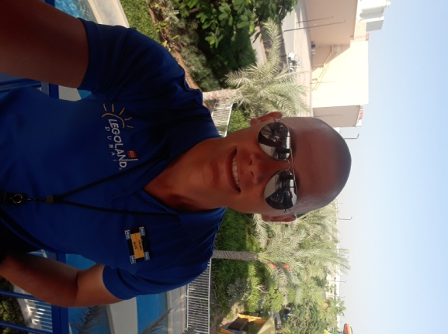
MILOS VUKAJLOVIC
DUBAI PARKS AND RESORTS,LEGOLAND DUBAI
WATER PARK, LIFEGUARD

+971-525064436
milos.vukajlovic92@gmail.com

PROFILE

- Address: Dubai Investment Park 1,RDK Building 2 Block C , Dubai , UAE
- Telephone Number: Mobile: +971 52 506 44 36
- E-Mail Home: milos.vukajlovic92@gmail.com
- E-Mail Work: milos.vukajlovic92@gmail.com
- Age: 25
- Date of Birth: 02/07/1992
- Nationality: Serbian
- Id Number: 0207992723215
- Gender: Male
- Marital Status: Married
- Home Language: Serbian
- Interests: Computers, Motorcycles , Lifeguarding
- Sports: Running, Swimming, Powerlifting

EDUCATION

2006 – 2010 School of Electrical Engineering - Software Programmer

EXPERIENCE

Currently working at Dubai Parks and Resorts, LEGOLAND Dubai Water park
As a Lifeguard

- Maintaining 10/20
- Guest Interaction on daily basis
- CPR Training certified ,, SGE – Star Guard Elite “
- Assisting with VAT (visual awareness training) and R&R (recognize and respond) with supervisors
- Competed in UAE Lifeguard Championship 2016 for LEGOLAND Dubai Water park
- Help to train colleagues with swimming
- Pre Opening Team 2016
- Started cross training for Team Leader / Head Lifeguard on 02.11.2017
- Successfully finished cross training for Team Leader / Head Lifeguard on 18.12.2017

Sport Center “AQUA PARK” Serbia, Complex of swimming pools and “ Sumarice “ Hotel, Lifeguard Supervisor and Lifeguard Instructor for 2 years
- Inventory for Lifeguard equipment
- Organizes Monthly events
- Manning 60+ Lifeguard that reports to me, and ensuring that they are briefed on daily duties and requirements
- Updating colleague monthly performance, training reports and misconduct reports
- Use of equipment knowledge
- Instructing and teaching new lifeguards CPR, rescue techniques, equipment knowledge, rescue breathing
- Maintaining company standard policies and procedures at all times

Sport Center “AQUA PARK” Serbia, Complex of swimming pools and “ Sumarice “ Hotel, Head-lifeguard and Lifeguard Instructor for 2 years
- Guest Interaction
- Enforcing Rules
- Manning a lifeguard station.
- Making sure swimmers keep within safe boundaries.
- Dealing with incidents eg: seizures, epileptic fitz , spinal injuries ,standard rescues
- Obtained ‘’RED CROSS’’ Lifeguard Instructor license

Sport Center “AQUA PARK” Serbia, Complex of swimming pools, Lifeguard for 2 years

- Maintaining 10/20
- CPR Training
- Swimming training
- Guest Interaction

SKILLS
- Ability to work under pressure
- Decision Making
- Conflict Resolution
- Leadership
- High knowledge of computer skills and programming
- Hard problem solver and willing to be trained
- First Aid trained
REFERENCE

Riaz Muzawar- LEGOLAND Dubai , Lifeguard Manager at LEGOLAND Water park
Mobile: +97150 349 65 14
Email: riaz.muzawar@LEGOLAND.ae

Feisal Hassan Abdullahi - LEGOLAND Dubai, Lifeguard Supervisor at LEGOLAND Water park
Mobile: +971 50 878 69 07
Email: feisal@LEGOLAND.ae

Reynaldo Solideo- LEGOLAND Dubai, Lifeguard Supervisor at LEGOLAND Water park
Mobile: +97156 686 23 15
Email: reynaldo.solideo@legoland.ae

