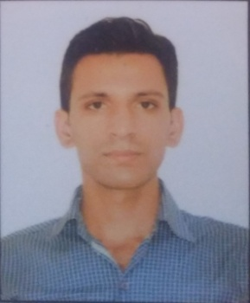

**AMIT KANDWAL**

Food & Beverage Associate

**Professional Abstract:** Exceptionallygifted and efficientF & B associate with flagship and pre opening hospitality and development with huge focus on training and development ensuring standards are met with wow ! factor. Almost 3 year’s extensive experience in development, talent acquisition, staffing and administration with exposure in International hospitality of the world. Has the drive to succeed and grow, setting ambitious goals coupled with the energy , motivation and commitment to achieve result. Has the courage to apply the necessary resources through informed risk taking to developed real opportunities into strategic businesses.

* [Amitkandwal1995@gmail.com 31c60c3fb908b2d959d3aa806d289061.png +97339104487  linkedin.com/in/amit-kandwal images (2).jpg Amit](mailto:Amitkandwal1995@gmail.com%20%20%20#  Amit) Kumar 718953.png Manama, Bahrain

 **Synopsis**

* A quick learner with the ability to work in as a team, flexible and organizes things with optimistic way for the betterment of the organization.
* Very innovative with a wide spectrum of knowledge.
* An effective communicator with excellent interpersonal & relationship building skills.

** Work Experience**

**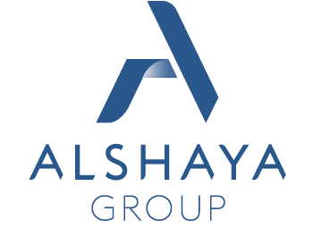**

** 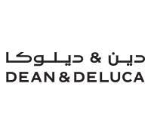**

**Food and Beverage associate in Bahrain October 2017-Present as a opening team member.**

* Maintain Standard operating procedure to opening & closing responsibilities of the restaurant.
* Ensuring maximum customer satisfaction by closely interacting with guest.
* Suggestive sale of Food and beverage products to the increase the revenues of the outlet as insuring the guest satisfaction.
* Responsible for the smooth operations.
* Ensure the highest standards to be maintained at all times.
* Ensure that Audit Scores are always maintained and improving at all time.
* Take care of barista & stores inventory.
* Taking care of international and V.V. I. P guests.

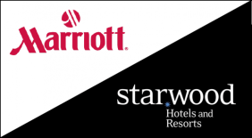

 **Food and Beverage associate in India (Delhi) June 2016 – August 2017**

* Ensuring maximum customer satisfaction by closely interacting with in – house guest.
* Maintain Standard operating procedure to run the outlet.
* Responsible for promotional strategies and for development in the Department.
* Ensure that Audit Scores are always maintained and improving at all time.
* Ensure the highest standards of courtesy and customer care are set and maintained.
* Responsible for providing efficient service to ensure customer delight.
* Inspect and ensure functioning of all the facilities in the operational area.
* Handling the station assigned for the day.
* Take care of bar inventory.
* Delivering high standard of service in all the situations.
* Maintain on daily basis HACCP record.



**Industrial training in India (Delhi) July 2015 – December 2015**

** Strength**

* Time and Task Management.
* Remembering guest preference and sharing it with the team.
* Never compromise with the brand standard which is laid by the company by adhering Zero tolerance.

**5a9c4bf9fb1dade77c30db604d886bfa_icon.png Personality**

* Passionate, Confident, Genuine.
* Creativity
* Organized

** Skills**

* High potential leadership quality.
* Team building developer & International pre- opening experience.
* Strong in restaurant operation & solid food and Beverage background.

**C:\Program Files\Microsoft Office\MEDIA\CAGCAT10\j0205582.wmf Software skills  Language**

Microsoft office English

Opera  Hindi 

Micros 

IDS 

** Professional qualification**

Bachelor of Hotel management from IHMS (Uttarakhand) 2013 – 2016

**1064024-200.png Training & Courses**

* Training on standard operating procedures in tasks pertaining to food and beverages services in restaurant.
* Training on beverages (Alcoholic) wines, Spirit, Cocktails.
* In-house training in interpersonal, negotiation and communication skills.
* Basic food safety.
* Loss prevention handbook.
* Fire & safety.

**396446-200.png Achievements**

* Awarded best suggestive salesman of Beverages.
* Guest satisfaction index target achieved.
* Achieved 1st winner of highest ATV by ‘Dean & Deluca’ Alshaya.
* Achieved hospitality hero pin by ‘Dean & Deluca’ Alshaya.

**PERSONAL TRAITS**

Loyalty and Quick learning are my assets and I believe in Smart work and want to learn new things in my life.

Date…

Place… (Amit)