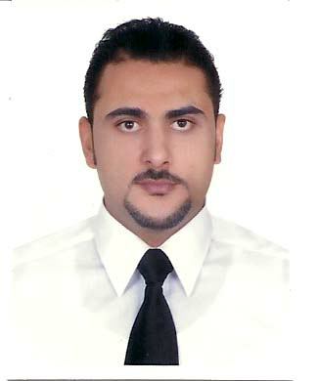
Kamal El-Garya

Mobile Phone - 00973 35 44 8765
E-mail - ayk442010@gmail.com

Retail store manager

12 years of experience as sales Excutive and supervisory level with excellent experiencein sales and administrative roles.
confident, competitive, and passionate about achieving sales performance and targets with high-level of customer service, build rapport with customers and sales staff and exceed expectation in up-selling,and customer retention.

Skills

- Excellent in the pursuit of organizational objectives.
- Speaks confidently, fluently & highly presentable.
- Market knowledge / research.
- Accepts and tackles demanding goals with enthusiasm.
- Quick Learner; develop and increase Company’s business.
- Takes a methodical and consistent approach towards customer services and achieving
Quality results.
- High negotiation skills.
- Excellent communication skills both in English & Arabic.
- Highly organized, goal oriented, and flexibility.
- Ability to foster a cooperative work environment.
- Excellent Computer skills and proficiency in MS Office Applications and internet
Research.

Career

(02/ 2014– 05/2018) Store Manager
(Aldo Group Intl) Call it spring …Dubai & Bahrain city centre.

*Responsibilities:

●ensuring the store operates within its predetermined budget*Salary, inventory, expenses,etc*
●ensures that all personnel practice professional salesmanship according to company policies,
Procedures in order to achieve maximum sales and provide the highest level of CS.
●adheres to and enforces loss prevention and security policies to all daily operations.
●ensure that all merchandise is properly ticketed and attractively displayed.
●designates and coaches ROS to assure proper merchandise at all areas in the store.
●communicates stock refills and allocation with merchandiser and the operation manager.
●conducting a training to sales associates to ensure high level of product kwlg, visual presentation, Sales techniques and administrative.
●enforces and complies with all store/company policies and procedures.

(12/2010-12/2013)... Supervisor
N style international – Urban Male Lounge (Dubai International Financial Center)

• Maintain professional relationships with suppliers and providers.
• Manage inventory effectively; follow purchasing standards; ensure compliance.
• Guide business decisions by staying on top of Spa industry trends.
• Consistently develop and grow retail sales through training, tools and monitoring.
• Monitor customer satisfaction with surveys focus groups and comment cards.
• Maintain Spa Administration and managing staff duty schedule, training,
Motivation, and briefing and maintain day to day operations.
• Manage reports, email, and maintain client's booking And Records.
• Developing and improving customer service standard at all times.
• Ensure equipment is maintained in good working order.

(11/2006 – 11/2010)… Sales Executive (jewellery & watches)
Aliali Jewellery… Burjuman Center-MOE

● increasing Sales and maintain Stock replenishment all times to insure optimum stock
At all the sections.
● maintain customer service and always seeking to improve it within the store.
● Maintain merchandize in sales Flore in line with the brand and company guidelines
And Report to the store manager for any shortage of product rang.
● Display all brands specific and generic marketing material.
● Ensure all products are prices tagged and bar-coded before display.
● Developing and managing positive learning and training environment for new staffs.
● Maintain store administrative and insure it's in line with company policy.
● insure sales target is achieved and exceed every month.
● monitor the presented display and sharing the team for taking action for none and slow
Selling items.

Education

Bachelor degree in Education

Your sincerely

Kamal El-Garya

