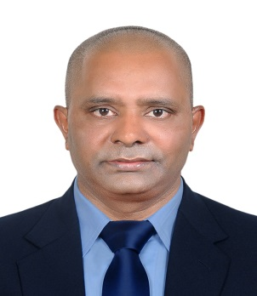

Objective
To be the part of an organization that provides me with opportunities & challenges, which will assist me to further develop on my abilities to learn, grow & explore in the field of Management & Guest Service. The Ideal position would allow me to share my experience for better results to the company as well as to the customers.

PERSONAL DETAILS

Name Menino Fernandes Sex Male
Nationality Indian Marital Status Married Religion Christian passport No B 0647728
DOB 24th December 1968 Place of issue Mumbai

CONTACT DETAILS

E-mail : meninofernandesmaria@gmail.com
Mobile : +971 - 507241033
LANGUAGE SKILLS

      - English Excellent
      - Hindi Excellent
      - Konkani Excellent

WORK EXPERIENCE

BURJ AL ARAB JUMAIRAH (DUBAI) UAE
Period : Since January, 2007 to till date
Designation : Bar tender

Jumeirah beach club and resorts (DUBAI) UAE

Period : Since 1st June 2001 until December 2007
Designation : Bar service waiter

Cricket club of India church gate, India

Period : Since May 1999 until june2001
Designation : Waiter

Candies confectioners and caterers- Mumbai India

Period : Since January 1988 until March 1999
Designation : counter sales representative

PROFESSIONAL SKILLS

- Having good knowledge of Info genesis revelation Window version Point of sales (POS) in Micros operations and symphony
- Cashiering and Credit Card settlement
- Making requisitions (ADACO.net)
- Always makes sure that the target are met as per company requirements
- IT skills: MS Office and Internet explorer
- Ability to persuade, build strong relationships and present solutions.
TRAINING AND ACHIEVEMENTS

- Completed ‘First Aid and Fire Safety’ Training
- Recently completed online course ( lobster ink ) food and beverage
- Completed WSET level 1 foundation in wines and sprits
- Basic Food Hygiene (H.A.C.C.P.) Certificate
ACADEMIC QUALIFICATIONS

- “Higher Secondary school certificate ” Mumbai India

I assure that attached information is true & accurate. In the event of being given an opportunity, you are assured to carry out my duties to the best of my satisfaction of all concerned.

MENINIO FERNANDES

