Antonina Seghedii  Briceni City, Corjeuti village, MD 2024  Home: 024757726; Cell: +373 68541790; email: seghedii_antonina@yahoo.com | 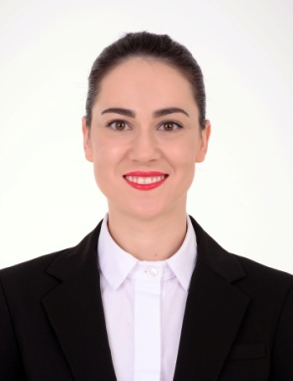
Professional Summary
- Organised Front Desk Agent with strong interpersonal and computer skills. Background in customer service and support and accustomed to managing difficult client situations;
- Dynamic Hotel Desk Clerk highly successful at juggling multiple priorities while delivering superb service with a smile. Computer-savvy and organised with strong attention to detail;
- Flexible to changes;
- Quick accommodation in team.
Skills
- Front desk experience;  - Quality assurance;  - Computer knowledge;  - Team building  - Concierge background;  - Five-star hotel experience; | - Service-orientated;  - Skilled negotiator;  - Food and beverage services;  - Internet Explorer, Opera, Microsoft Office, Excel knowledge;
Work History
01/2017 - Current | Receptionist  Radisson BLU Leogrand Hotel Chisinau  - Welcome and greets guests with great courtesy;  - Address guests concerns and special requests in a professional and personable manner;  - Ensure that guests are settled comfortably in their rooms, makes necessary adjustments if needed;  - Get transport for customers and reservations in local restaurants;  - Receiving all incoming calls and ensuring their distribution to the relevant employee;  - Communicate with housekeeping and maintenance staff to ensure that great quality service is provided to guests;  - Deal with complaints and problems;.  - Delivered messages, mail and packages left for guests and hotel facilities in a timely manner.  - Reviewed account information and charges with guests during check-out.  - Researched and updated all required materials needed for firm and partners.

01/2015 - 08/2017 | Secretary  State University of Physical Education and Sport – Chisinau, Moldova

12/2014 - 05/2015 | Physical education teacher and Physiotherapist  High school of children with poor vision – Chisinau, Moldova

06/2014 - 09/2014  05/2013 - 09/2013 | Salad maker  Harrison's Harbor Watch” Restaurant – Ocean City, Maryland, USA

Education
June 2017 | Master Degree “Dunarea de Jos” Galati University -  Physiotherapy at home;

May 2016 | Master Degree “Technologies and Management in Tourism”  University of Physical Education and Sport - Chisinau, Moldova

May 2014 | License Degree: Faculty of Physical Therapy  State University of Physical Education and Sport - Chisinua, Moldova

May 2010 | Corjeuti Lyceum

May 2007 | Corjeuti Elementary School
Personal Information
Nationality: Moldavian
Marital Status: Single
Date and Place of birth: March, 24th 1992, Moldova, Corjeuti village, Briceni City
Interests
Reading, travel, sport
Languages
Romanian, Russian and English.

