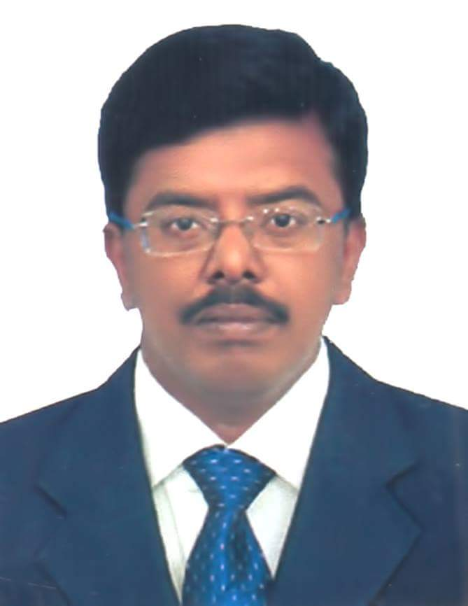

ABDUL WAHEED ABDUL SALAM

I am a self-motivated, Team Motivator, willing to take up any challenges having 21 years of experience covering Banking Sectors, financial field and in Facilities Management, housekeeping module.

NAME : ABDUL WAHEED ABDUL SALAM
FATHER’S NAME : ABDUL SALAM
DATE OF BIRTH : 13 Jan 1972
NATIONALITY : INDIAN
MARITAL STATUS : MARRIED
CONTACT NUMBER : 0569975079/052289459
Passport No. : K 2496860 VALID until 8 Jan 2022.
LANGUAGES KNOWN : TAMIL (Native or bilingual Proficiency)
HINDI (Native or Bilingual Proficiency)
ENGLISH (Professional Working Proficiency)
ARABIC (Elementary Proficiency)
Nepali (Elementary Proficiency)
Malayalam (Elementary Proficiency)

EDUCATIONAL QUALIFICATION;
H S L C (HIGHER SECONDARY LEAVING CERTIFICATE) AT J B A S HR SEC SCHOOL IN THE YEAR 1990.
Bachelor of Computer Science Graduation from THE NEW COLLEGE.BATCH 1990-1993.course completed.

CURRENTLY : joined FARNEK Services LLC on 2 August 2016 and now, placed at The Dubai Mall from 16th January 2018 as a duty officer at Fashion Avenue Expansion handling 89 staffs. From the construction site, the mall was mobilized on 5th March 2018, and taking care of staffs welfare, logistics, absenteeism control, trainer, operational needs, stores in charge, coordinating the staffs support on busy days and an advisor for the staffs.
Promoted as Assistant facility manager for The Dubai Mall from 1st June 2018, and now taking care of L&E, the entertainment area.
Snag reports for the areas washrooms, escalators, balcony balustrades, common areas, elevators, lobbies and hand railings were updated as per expected. Shifts and shift breakups drafted for the smooth operations up to standards. Logistical coordination for the shifts, updating attendance summaries, stocks inventory, uniforms inventory, man-hour management, preparing PPMs, proactive and reactive maintenance, managing the supplies, equipment’s, consumables, chemicals and their store arrangements.
conducting tool box talks, documents controller, daily cleaning reports, staffs welfare and covering staff numbers as per the Bill of Quantity on shifts basis, trainings to the staffs and supervisors for the equipment’s and chemicals usages.
Documentations well maintained and attendance sheets, TBTs, delivery notes, raising MPRs for the purchases required, stocks inventory on a day-to-day basis and request upon the usages are my Job descriptions and well maintained.
Keys handling registers, washrooms check lists, common areas check lists, janitor rooms check lists, hand over and take over formats, and staffs movements in common areas, back houses.
Cleared back house areas as scheduled PPMs, schedules for the cleaning standards, documenting the activities in and around the premises as on cleaning structures are my planned actions, which has been fruitful for the clients.
During preopening days, the entire cleaning Team were covering the Back of House areas, picking the litters in huge, removing construction wastes, wooden pallets, rubbishes and trashes left over by the construction site contractors were maintained as per standards
DUBAI PARKS & RESORTS
: Prior to TDM, was at Dubai Parks & Resorts, Dubai, Jebel Ali as Soft services Executive from September 2016.
Managing all the parks operations, deploying and allocating staffs in the parks, transportation coordinator, planning proactively for the delivery of staffs foods and refreshments, staffs Bill of quantity requirements for each parks, staffs absenteeism’s, additional staffs at the busiest days allocated, grand opening day, national holidays and camp coordinator.
All the located areas, pantry, offices, janitor rooms, corridors, stairs were covered with checklists from October 2016 for standardized cleaning.
Washrooms check lists were in place from September 2016 and carries shift wise break up as per standards.
Allocation plans is in use from November 2016 and supervisors cover their shifts duly this plan.
Plan of actions are in place from March 2017 and stands for the tasks for the shifts allocated and followed up.
Janitor room’s setup checklists carry all the cleaning equipment has and tools required as a minimal need and effective.
Schedules for deep cleaning and Planned Preventive Maintenance is into effect from November 2016 and maintained a good track on the cleaning standards.
All the cleaning equipment is and machines from Taski, Karcher and Tennant has a proper record of accomplishment on the sources from Invoice, delivery notes, servicing records, wear & tear accessories as well.
Equipment’s checklist displaying the usages, maintenance and servicing is live and supervisors to follow the machines and update on a daily basis.
Shift hand over Reports, daily cleaning Reports are on mailing after the IT Team opened a mailing access for all the supervisors
During preopening days, the entire cleaning Team were covering the Back of House areas, picking the litters in huge, removing construction wastes, wooden pallets, rubbishes and trashes left over by the construction site contractors from the period September 2016 until December 2016 and ongoing.
Our other service providers DULSCO, IMDAAD pest control team, GRAKO façade cleaning Team had a unique coordinating support and we could deliver the cleaning standards from the waste management until façade cleaning, pest-controlling treatments were on a positive sign.
Grand opening on December 2016 where additional staffs around 100 from Farnek planned designated as per needs and the park well maintained as per standards.
Attendance sheets and invoice signed papers were drafted and implemented.
COSHH cards were made into practice for Diversey chemical and approved
Innu science chemical at Riverland on a trial basis for 15 days at May 2017.
Washrooms Do’s and Don’ts, Park Cleaning Standards (Front of the house and Back of House) were identified and put into use.
Standard operating Procedures and risk assessments created and implemented as a standard practice.

ESS COMPASS:
Joined ESS COMPASS on 14 Feb 2012 as a Cleaning supervisor in the Location Doha International Airport, promoted as a Zone Manager on December 2014.
Covered all the Locations in DIA, with the significant training and controlling the Team by Zero Absenteeism’s, Providing training to the staffs frequently, follow the tasks assigned and completing the tasks within the specified time.
Had a good relationship with the clients and maintaining the Quality of work delivered consistent.
Transferred to Camp Administration for 4 Months short period, which gave me a real Exposure to Camp Maintenance. Catering, Laundry, transportations, facilitating staffs with at most care, maintaining standards in the Villas was my achievement.

TRAININGS AND AFFILIATIONS:
BICS, Chemical competencies, Knowledge over all the equipment are my added advantage.

BICS accessor from January 2016 at ESS COMPASS, Qatar.
Time Management, Train the trainer, MAPPING business, Environment study, business and cost control training are the major course of training.
Single Disc, Multi Disc, scrubber dryers, High Wall cleaners, Escalator Cleaners and every Equipment which are related to cleaning and House Keeping are easier to work and can give training in this.
TRAIN THE TRAINER, Time Management, Effective communication, Fire safety, Basic First Aider, Training s from KIEHL and from Hagodor are my knowledge over chemicals.
ESS COMPASS has given me training in Quality Level at work, building relationships, safety measures, Indulgence, Teamwork, Passion towards Quality, and be an Integral Employee.
Scaffoldings, Water Pole Cleanings for External Glass Cleanings were under Special Team and I handled personally as per Standards.
Basic First Aid and CPR training completed with Enertech, Qatar.
Basic Fire Fighting Training completed with Enertech, Qatar.
Training from KIEHL, Chemicals Co. frequently and implementations of new ones as per needs was a success.
Training from Taski Electronics and usages frequently to the staffs and implementing it.
Training from Karcher Electronics regarding machineries Use and Maintenance Issues.
Training from Management Training Consultants, Unleashing your Potential on 6 December 2014.
Accessor Certificate from British Institute of Cleaning Science, on 27th January 2016 was completed with good Skill and Performance.

ACHIEVEMENTS:
Relationships with the Clients and maintaining the Work Station clean as per the standards, Good way of communications with the Passengers, Updating the Maintenance Requests, covering all the Quality Measures in the Concourses, Good level of Shift Hand Over and Take Over even in the busiest Time are my achievement.
Being responsible for almost 1000 staffs, well trained in handling staffs through our Parameters, Health and Safety, Team Work, Responsibility, Can Do and in Integrity. We did make sure all the staffs given Equal Opportunities from their Accommodation Level, Transportation, Medicals, Day offs, Regional Festivals and their Customs, Staffs Attendances monitored on Each Shifts. Multi Languages handlings among the Staffs, Keep an Eye on the Busiest Passengers Flights schedules and complying with the Necessary Back Ups, Mess Halls for the Staffs for their Break without avoiding the Necessary Planned Staffs Placements in each Shifts had made me well exposed to Non Stressed Job Satisfaction.
4 Million LTI from the Project Doha International Airport and Hamad International Airport.
Consistent Zero Penalty from Joint Inspections, 20 per day were complied.
Responsible and was covering SAP Formula for the Stores and Records.
From March 2015 till July 2015, given additional responsibility and was transferred to Camp as Camp Boss at Street 41 and 43, Al Saniya, Qatar.
Responsible for staffs from Doha International Airport, Aspire Zone and Hamad International Airport and their Transportations for the three Shifts with 22 Transports were my huge task and controlled it in style.
Foods from CPU, Food Counts and Food delivery, Kitchen and Serving Centers Quality maintained neat as per standards.
Controlled medical checkup, staffs Health care with One OHS Nurse as per Qatar Standards.
Weekly client Meetings with the Clients at Client’s office with the necessary Updates and Track Records as per Qatar Airways and Hamad International Airport authorities made my Compass Group more reliable.

INDIA:
Worked as a Sales Manager at ABN AMRO BANK, CAR LOANS SEGMENT from Feb 2002 until Nov 2005.my job was to make my team in an ascending growth, responsibility for the Car Loans, Car bookings, confirm the Loan process, and follow Insurances, Car Registrations and Delivery of car to the clients.
Entirely responsible after Promotion, with the Team to move around the Market, Training the Team, motivating them and succeed regarding the Target Based Career.

Worked as a Sales Manager at ING VYSYA BANK LTD from Nov 2005 until April 2009.
Team motivation oriented and a big task target oriented, Competitive Team did dominant achievements in configuring Targets, Tie Up with the available Car Showrooms, Road Shows Advertisements, consistent follow up with the clients was my achievement.
_____________________________________________________________________________________________
REFERENCE:
Mr. Aji George,
Facilities manager,
Dubai Parks & Resorts,
Jebel Ali.
Dubai.
Contact No. 971556225410.

Regards,
Abdul Waheed Abdul Salam

